S-3 EUROHAB Stakeholder Workshop Report
10th May – Exeter Racecourse

The first S-3 EUROHAB stakeholder workshop was held at Exeter Racecourse on 10th May 2018. It was well attended with 26 stakeholders present who represented a range of interests: 11 representing shellfisheries and 18 representatives of the monitoring system but also members of conservation organisation, of management bodies and academia.

Gavin Tilstone (Plymouth Marine Laboratory – PML), principal investigator of the project, introduced briefly the S-3 EUROHAB rationale: developing an online system for detecting Harmful Algal Bloom (HAB) and poor water quality. The project will focus on five algal species:
- Psedo nitzchia, which can cause amnesic shellfish poisoning;
- Dionphysis, which can cause human gastrointestinal problems;
- Karenia mikimotoi and Lepidodinium chlorophorum, which may cause oxygen depletion and thus fish and shellfish mortality;
- Phaeocystis globsa, a foam producing species that can clog the gills of fish and shellfish. It is also considered unsightly.

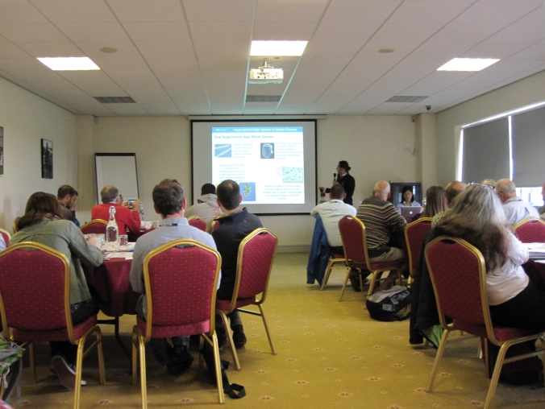

Brief introductions were also given by:
- Caroline Hattam (PML) who spoke about how S-3 EUROHAB also aims to better understand the economic and social impacts of HAB events in the Channel, as well as any potential benefits stemming from the implementation of the web alert system.
- Mike Best (Environment Agency – EA) who gave an overview of HAB events in the Channel region, their causes and consequences.

The workshop was divided into three parts involving small group discussion:
- Understanding the ecological impacts of HABs and how these translate into social and economic impacts
- Understanding the strengths and weaknesses of the existing HAB monitoring systems for shellfisheries and bathing waters
- Development of the web alert system.

1. Ecological, social and economic impacts of HABs

1.1 Ecological impacts
In breakout groups, participants were asked to review a “map” of the main ecological impacts resulting from HABs and to add any information missing.

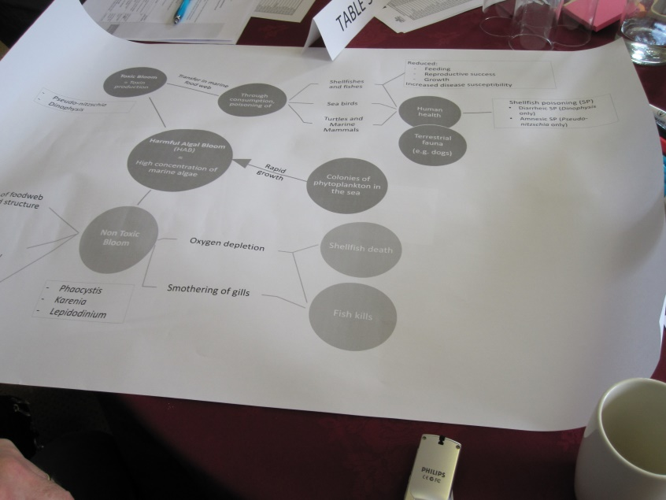
2. Picture of the map of the ecological impacts of HABs

Various additional ecological impacts were mentioned by the stakeholder, some of them linked with each other:
- Ecological impacts: participants highlighted that oxygen depletion due to HAB events is relevant for both toxic and non-toxic blooms.
- Impacts on human health: the impact of spray from toxic species in the air was raised as they may have respiratory impacts.
- Impacts on non-shellfish species: invertebrates, such as starfish, have found to carry high concentrations of some shellfish toxins. For example, starfish off the coast of north Norfolk were found earlier in 2018 to contain saxitoxin (the toxin responsible for Paralytic Shellfish Poisoning) at a concentration of 20,000 parts per litre (compared to the trigger level of 80 ppl that would result in the closure of a shellfish bed). Dabs, an important recreational fish species, were also found with high concentrations and it was thought that top food chain predators, such as seabirds, mammals can be impacted by HABs as well.

1.2 Social and economic impacts
a) Impacts on shellfisheries:
- Wild scallops and other wild shellfisheries are impacted differently to shellfish culture.
- For wild catch shellfish, the responsibility for paying for flesh testing lies with the fishermen. When an alert is in place, fishermen have to have their shellfish shucked by a registered shucker and pay for this themselves, resulting in reduced income from their catch.
- Product recalls of cultured shellfish can occur due to delays in receiving the results of shellfish testing. Such recalls result in a greater economic impact than bed closure.
- When shellfish beds are closed due to HABs, customers can go elsewhere and do not necessary come back once the shellfish can be harvested again.
- When a closure is implemented, bed owners employing harvesters still have to pay them despite their inability to work.
- HABs event have negative impact on people’s perception of shellfish consumption. Customer perception and public confidence is easily damaged. Negative publicity associated with HABs can lead to economic impacts and reputational damage. Some participants pointed out that a small closure (inferior to 5 days) builds confidence in the stock but a longer closure actually leads to lose in confidence.
- Closure of in fisheries in Wales and/or Scotland can have economic impacts on shellfish activities in the Channel because of the displacement of their fishing activities.
b) Impacts on monitoring organisations:
- When there is an HAB event, the extra sampling needed means that the Environmental Health Officers (EHO) need to do extra sampling, which means extra costs for the boat rental, EHO time and extra testing for Cefas.
c) Impacts on recreational activities:
- The foam produce by some HABs can impact recreational users (such as swimmers and water sports practitioners).
- Dog walkers and their dogs can also be impacted. In north Norfolk, dogs were ingesting washed-up starfish and those that were not rapidly treated died. Communicating to vets and the public ensued.
- HABs can also impact recreational sea anglers, an important contributor to the local economy in some coastal locations (e.g. toxic dab were found off the coast of n. Norfolk). There is a need to inform anglers when toxic HABs are detected.
- Discolouration of coastal waters due to HABs could lead to aesthetic impacts (loss of recreational/tourism experiences).
- Beach closures were raised as a possible impact. While this has not yet happened in UK, it was regarded as a possible consequence of HABs based on the experience of other countries (such as Netherlands).
d) Impacts on the health service
- Estimating the impacts on human health is challenging as doctors typically do not test their patients for toxic shellfish poisoning.
- Even though evidence for health impacts is poorly documented some participants suggested that the impacts on NHS could be substantial (millions of pounds a year).
- While it was considered that cases of death due to the ingestion of toxic shellfish in the UK were very rare (but not non-existent), deaths associated with shellfish consumption, as have occurred in the United States, were thought to have a catastrophic effect on the shellfish sector.
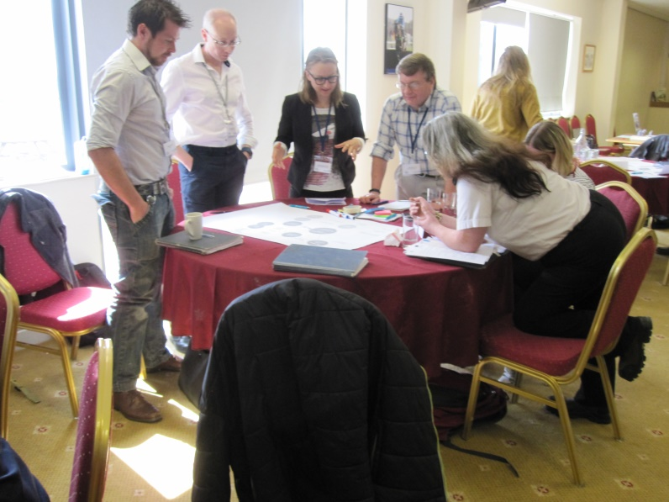
3. Stakeholders discussing the map of HABs impacts
1.3 Priority impacts:
When asked which impacts were perceived as the greatest, shellfishermen indicated that reputational impacts for shellfish businesses associated with closures were most significant, followed by general economic costs to the industry following a HAB outbreak.

Those responsible for monitoring and HAB management indicated concerns over the efficiency and cost effectiveness of monitoring, the ability to monitor offshore, but also reputational concerns for the shellfish industry.

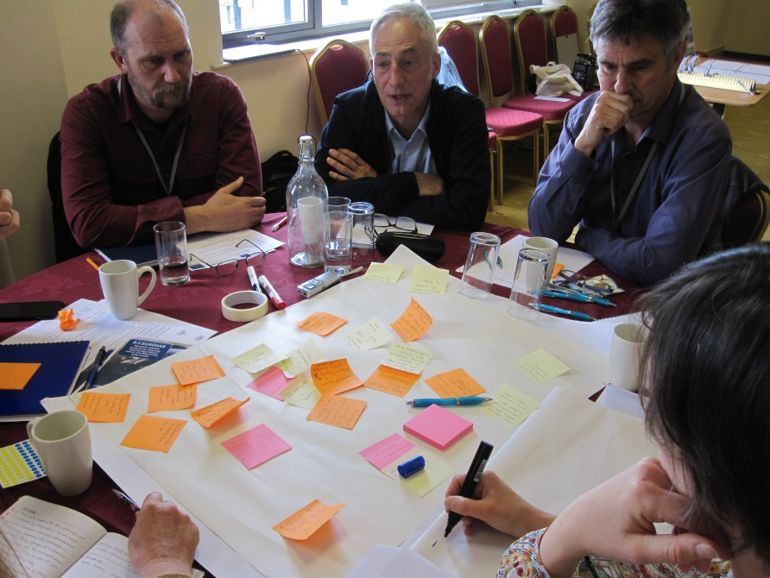

2. Strengths and weaknesses of the current monitoring system
Currently the FSA, as the competent authority, coordinate the HAB monitoring programme. CEFAS conducts the shellfish flesh analysis but does not make the decision to close/open a shellfish bed. The sampling routine depends on the season and the location:
- In areas with historic risk of PSP and/or insufficient historic data the monitoring take place fortnightly from the 01/04 till the 30/09 and every for week from the 31/09 till the 31/03;
- In areas with no historic risk of PSP and sufficient data the monitoring takes place four weekly all year;
- In areas requiring additional monitoring data, there is a weekly monitoring all year.
Sampling is undertaken by the local authorities (LA). LAs also enforce the closure and opening of the shellfish beds.

Some stakeholders stressed that the bathing water quality monitoring system is much simpler (the Environment Agency does weekly testing when the bathing season starts).

For HAB monitoring, the maximum permitted levels and trigger levels are as follows:

 | Maximum Permitted Limits | Trigger
PSP | >800ug/kg | >400
ASP | >20 mg/kg | >10
DSP | >160ug/Kg | >80
AZP | > 160 ug/Kg | >80
YTX | > 3.75 mg/kg | >1.8 mg

Stakeholders mentioned two closure options when the maximum permitted limits is reached:
- The bed is closed for the season (if no resources are available for extra monitoring);
- The bed is closed but resampled after 7 days. It is then sampled again at least 2 days apart until 2 clear samples are observed. Only then can the bed be re-opened.
Option 2 is most common.
Not all participants were clear about when a closure could be lifted. Delays in lifting a closure could have significant economic impacts for the shellfishermen.
In breakout groups, participants were asked to annotate schematics representing the current shellfish and bathing water monitoring systems for HABs and water quality. Key points arising from the discussions include:
- The main weakness of the current monitoring system was considered to be the time delay between the FSA knowing the results of the flesh analysis and the shellfishermen being informed. The delay can result in products being recalled from market, with implications for business reputation. Shellfishermen stressed the need for much faster communication.
- In Scotland, following incidences of shellfish poisoning due to toxic mussels, a traffic light system including an early warning system has been implemented. This traffic light system is ‘powered’ by the Food Standard Scotland’s official control results. It has three alert status: “green”, “amber” and “red”. The information received in the previous four weeks (i.e. a flesh or phytoplankton result) is used to then rate the risk and the action required (see table below, based on FSA report ).

Risk rating |  | Action
Green | No increase in End Product Test. Food Business Operator(s) should maintain routine verification checks
Amber | Increase frequency of End Product Test or positive release
Red | Cease harvesting unless evidence is available that product is safe

- The FSA and CEFAS commented that the current system is the best that they have at the moment considering the financial and economic resources available.
- Questions how the trigger levels are set were raised and whether they need to be reviewed. Trigger levels were established decades ago and may need updating.
- Concern that the whole scallop is being blended up for testing, but that only some part of the shellfish are going to be eaten. A testing technique focused on just the edible parts could be more relevant.
- Water monitoring was considered more important for shellfish bed classification than for HAB testing, however, there was concern about the representativeness of the water testing. Water samples are often from surface waters which may not be where HABs are and HABs in surface waters may not affect shellfish on the bed.
- Tetrodotoxin (TTX ) is not tested for, but new EU customers are now willing to test for this toxin.
- Rules in the UK are considered harsher than the EU requirements. The UK imposes a 2 week clean testing period following a HAB incident, which means that a minimum closure period is normally at least 3 weeks. EU legislation only requires a 48 hour clean period.

Opportunities for improvement were identified including:
- Shellfishermen suggested that the FSA could put the results online or send the results by email or text messages, in addition to informing the EHO of the LA concerned, to increase the speed of the reporting, especially when beds are closed (or about to close).
- More adaptive and more frequent sampling was also suggested including the development of rapid testing kits that could help to check conditions in the field and trigger an investigation.

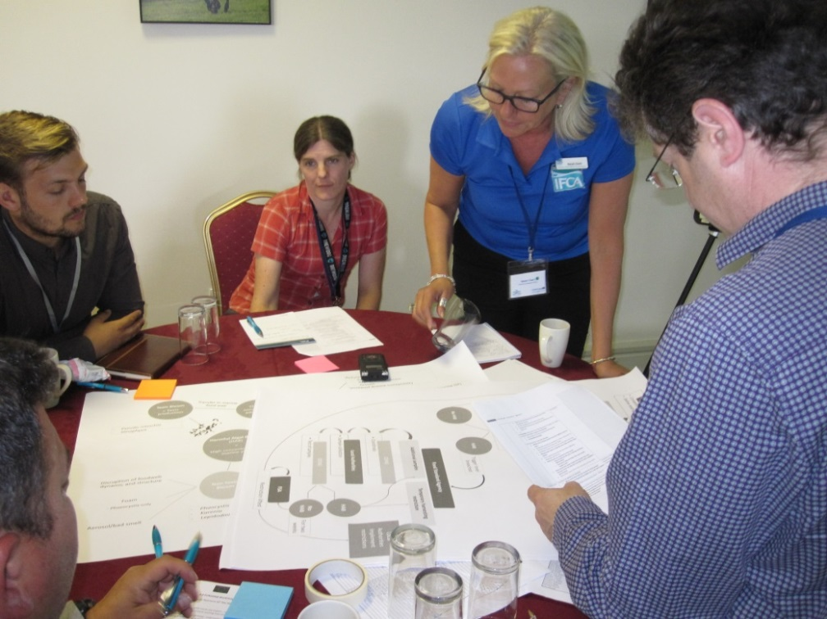
3. Development of the web alert system.
The final session of the day introduced the web alert system that S3-EUROHAB will develop and asked participants to indicate the types of data that they would benefit from being included in the alert system. 24 stakeholders answered the survey (UK). A summary of findings is below (multiple answers were allowed):
- Regarding the geographical area covered by the web alert system, the most popular areas are Lyme Bay, the South Coast of England and the English Channel as a whole;
- The most requested in situ data are: sea temperature, water transparency and phytoplankton. 18% of respondents are willing to receive data on all the proposed parameters (sea temperature, salinity, nutrient level, HAB, phytoplankton, wind and current);
- Stakeholders were mainly interested in the following satellite data: specific HAB species, such as karenia, alexandrium, dinophysis, Pseudo-nitchia, phaeocystis, gymnodium, chlorophyll – ocean colour and total suspended matter;
- Regarding the format of the data, stakeholders were mainly interested in getting colour scale maps, raw data and time series;
- The most requested resolution is 60m, followed by 1km and 300m.

